COMPANION ANIMAL/EQUINE SUBMISSION FORM |  |  | Gribbles  VETERINARY
Lab No.  (for office use only) | URGENT | 1868 Dandenong Rd, Clayton VIC 3168  “VETLAB” 33 Flemington St, Glenside SA 5065  32-40 Bigge St, Liverpool NSW 2170 | HELP DESK 1300 307 190

Owner Name: [openvpms:get(party:getPatientOwner(.), 'lastName')] |  |  | Animal ID: patient.entity.uid; “patient.entity.name“ |  |  |  | VETERINARIAN / CLINIC
Species: patient.entity.species | Breed: patient.entity.breed | Age: patient.entity.dateOfBirth |  |  | Sex: patient.entity.sex |  | #2010 - clinician.entity.name  PARADISE VETERINARY HOSPITAL  655 Lower North East Road  Paradise SA 5075  Tel: 08 83374922 Fax: 08 83379628
Owner Address |  |  |  | Postcode
Previous Lab Number |  |  | Clinic Reference |  |  | Clinic Fax
HISTORY & OBSERVATION (clinical signs, duration of illness, feeding, condition, pregnancy, description of lesions)
product.entity.name
...........................................................................................................................................................................................................................................................

...........................................................................................................................................................................................................................................................

...........................................................................................................................................................................................................................................................

...........................................................................................................................................................................................................................................................

Current Therapy / antibiotics / vaccination.........................................................................................................................................................................................
SAMPLE SITE / ORIGIN |  |  |  | PROFILES |  | CYTOLOGY
Please complete |  |  |  | 2500 Complete biochemistry  6230 Health Screen  6238 Wellness profile  Total Body Function  6304 Annual Health Profile  6308 Geriatric profile (feline)  6309 Geriatric profile (canine)  6306 Sick dog profile  6307 Sick cat profile  1600 Coagulation profile  6299 Equine racing profile  6280 Greyhound racing profile  6260 Pre Anaesthetic profile  6210 Liver profile |  | 4130 General Cytology  3530 CSF analysis – no C&S  3531 CSF analysis – with C&S  3520 Fluid analysis – no C&S  3510 Fluid analysis – with C&S  Fluid collection site  Thoracic / Pleural fluid  Abdominal / Peritoneal fluid  Joint / Synovial fluid  Tracheal wash / BAL  FNA / Other.......................................
BLOOD | EDTA  Plain  Lith Hep | Citrate  Fl Ox  Gel
SMEARS | Blood | Other
URINE | EDTA | Plain
FLUID | EDTA | Plain
 |  |  |  |  |  | MICRO/URINE
3110 Culture and Sensitivity

Collection site.........................................
3400 Urinalysis
3410 Urinalysis with C&S
2345 Urine specific gravity
Urine method of collection

................................................................
3160 Fungal wet mount & culture
3250 Faecal endoparasites, C&S
3251 Faecal endoparasites, occult blood
3252 Faecal endoparasites, occult blood, C&S
SWAB | Gel | Dry
 |  |  |  | THERAPEUTIC DRUG MONITORING
TISSUE | Formalin | Fresh
2630 Phenobarbitone
2620 Digoxin
2640 Cyclosporin
FAECES | Fresh | Formalin
OTHER
 |  |  |  | HAEMATOLOGY
6229 Partial blood count (PBC)
1100 Full blood examination (FBE)
SKIN BIOPSY/MASS (please mark where taken)
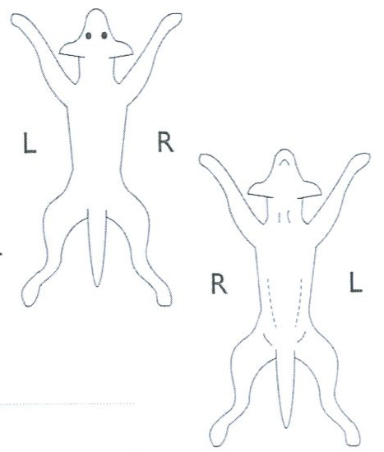
DORSAL VENTRAL
 |  | ENDOCRINOLOGY
2510 ACTH stim test
2510 Overnight Dex supp test (Equine)
2510 Low dose Dex supp test
2510 High dose Dex supp test
2531 Total T4
4256 Free T4 by Equilibrium Dialysis
2550 Progesterone
 |  |  |  | HISTOPATHOLOGY
4110 Biopsy
4120 Necropsy tissue
 |  |  |  | OTHER (please specify test required)
.................................................................

.................................................................

.................................................................

.................................................................
 |  | SEROLOGY
3653 FeLV Ag
3654 FIV Ab
4256 FIV PCR
3655 FeLV Ag & FIV Ab
2531 Foal IgG
3710 Toxoplasma (IgG & IGM comb.)
Fasting Non Fasting | Specimen Collected Jul 6, 2010 at ............. hours
................................................................................................................. ..Jul 6, 2010
VETERINARIAN'S SIGNATURE (clinician.entity.name) DATE

